EXPERIMENT NO:24

Design DFA using simulator to accept the string having ‘ab’ as substring over the set {a,b}

AIM: To Design DFA using simulator to accept the string having ‘ab’ as substring over the set {a,b}

INPUT:

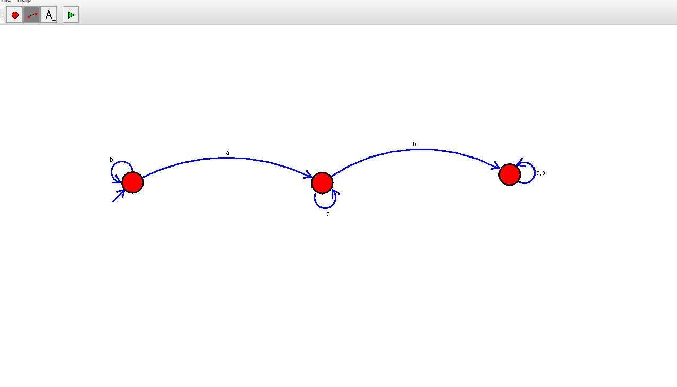

OUTPUT:

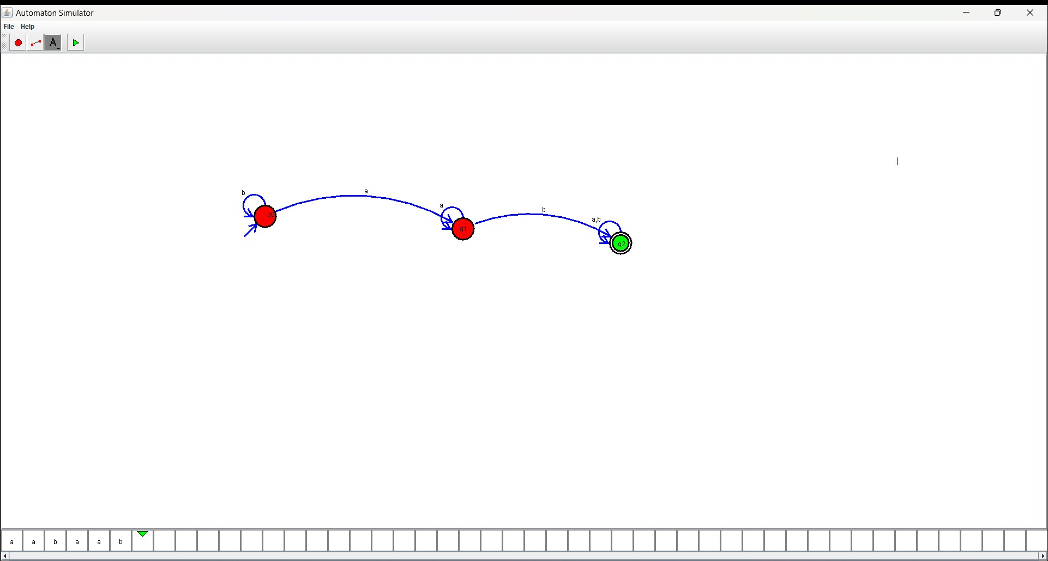

RESULT: The program executed successfully and got output.